**C programming practical file:**

Name: Raju Rai

Roll:29

Faculty:Bsc physics

**Program-1(WRT program to display the hello world)**

#include <stdio.h>

#include<conio.h>

int main() {

printf("Hello, World!");

return 0;

getch();

}

OUTPUT:

Capture1.PNG

**Program-2(WRT program to add any two numbers)**

#include<stdio.h>

#include<conio.h>

int main() {

int number1, number2, sum;

printf("Enter two integers: ");

scanf("%d %d", &number1, &number2);

sum = number1 + number2;

printf("%d + %d = %d", number1, number2, sum);

return 0;

getch();

}

OUTPUT:

Capture2.PNG

**Program-3 (WRT program to swap any two numbers)**

#include<stdio.h>s

int main() {

double first, second, temp;

printf("Enter first number: ");

scanf("%f", &first);

printf("Enter second number: ");

scanf("%lf", &second);

temp = first;

first = second;

second = temp;

printf("\nAfter swapping, firstNumber = %.2f\n", first);

printf("After swapping, secondNumber = %.2f", second);

return 0;

}

OUTPUT:

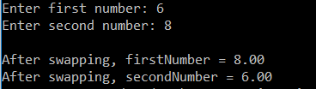

**Program-4 (WRT program to any two numbers)**